Decagon
# Source: AI Source: Provided by: [Data Path: Persons Table -> ID Column: 1, Name_En Column: Motasem Essam] -> From: [ChatGPT] on [7/25/2026]
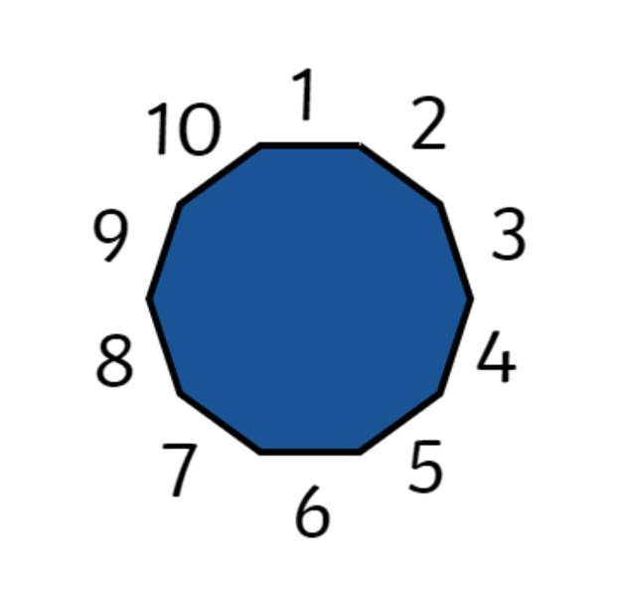
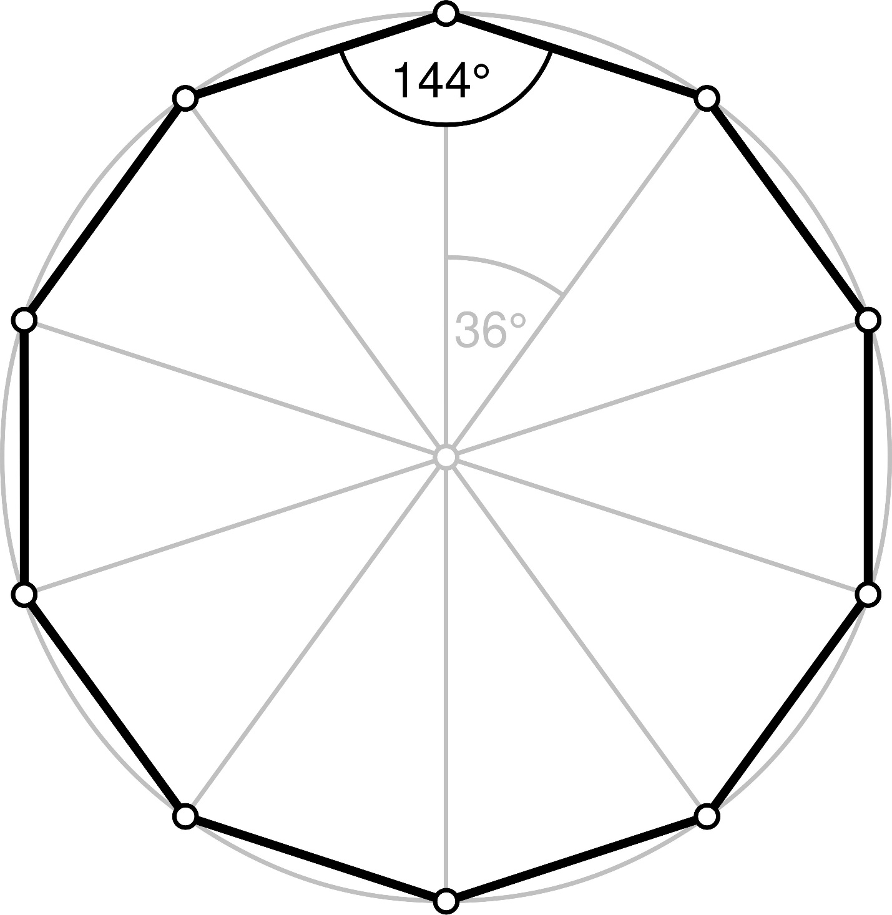
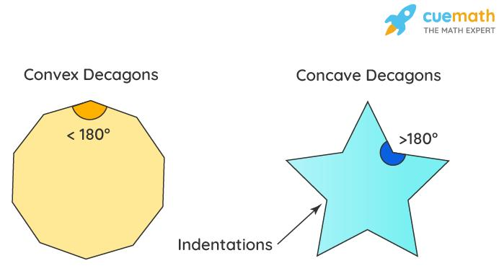
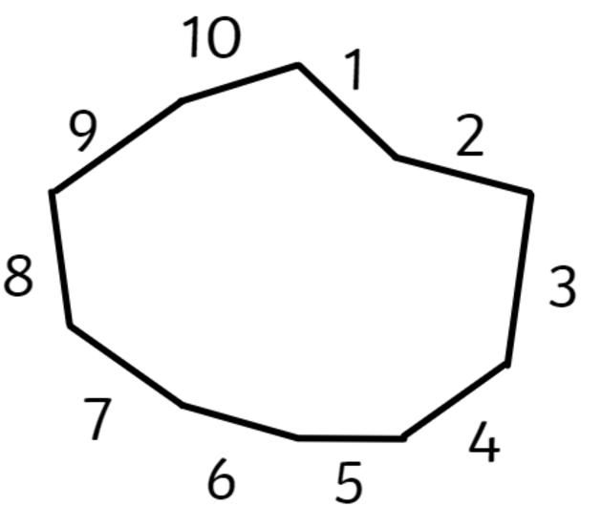
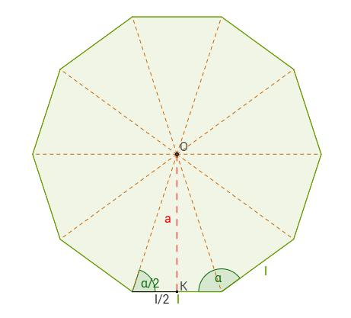

Definition
# Source: AI Source: Provided by: [Data Path: Persons Table -> ID Column: 1, Name_En Column: Motasem Essam] -> From: [ChatGPT] on [7/25/2026]
A decagon is a polygon with ten straight sides.
Therefore, a decagon has:
- 10 sides
- 10 vertices
- 10 interior angles
- 10 exterior angles
- 35 diagonals
A decagon may be convex or concave, regular or irregular, and symmetric or asymmetric.

Fundamental Elements
# Source: AI Source: Provided by: [Data Path: Persons Table -> ID Column: 1, Name_En Column: Motasem Essam] -> From: [ChatGPT] on [7/25/2026]
Consider a decagon $ABCDEFGHIJ$:
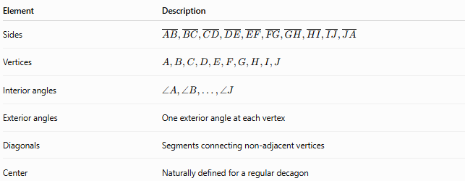
Element | Description
Sides | $$\overset{‾}{AB},\overset{‾}{BC},\overset{‾}{CD},\overset{‾}{DE},\overset{‾}{EF},\overset{‾}{FG},\overset{‾}{GH},\overset{‾}{HI},\overset{‾}{IJ},\overset{‾}{JA}$$
Vertices | $$A,B,C,D,E,F,G,H,I,J$$
Interior angles | $$∠A,∠B,…,∠J$$
Exterior angles | One exterior angle at each vertex
Diagonals | Segments connecting non-adjacent vertices
Center | Naturally defined for a regular decagon

Classification of Decagons
# Source: AI Source: Provided by: [Data Path: Persons Table -> ID Column: 1, Name_En Column: Motasem Essam] -> From: [ChatGPT] on [7/25/2026]
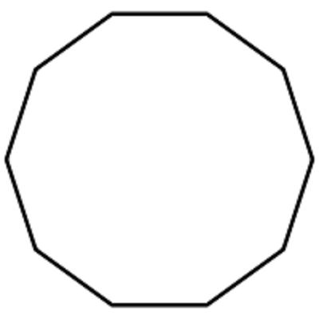
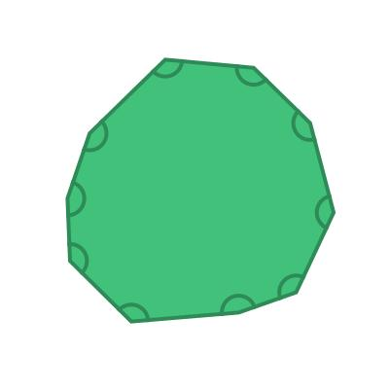
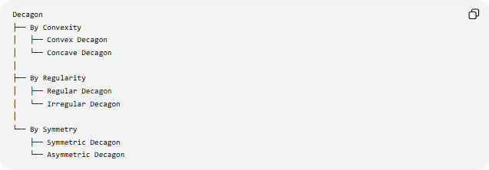
Decagon
├── By Convexity
│ ├── Convex Decagon
│ └── Concave Decagon
│
├── By Regularity
│ ├── Regular Decagon
│ └── Irregular Decagon
│
└── By Symmetry
├── Symmetric Decagon
└── Asymmetric Decagon

Convex Decagon
# Source: AI Source: Provided by: [Data Path: Persons Table -> ID Column: 1, Name_En Column: Motasem Essam] -> From: [ChatGPT] on [7/25/2026]
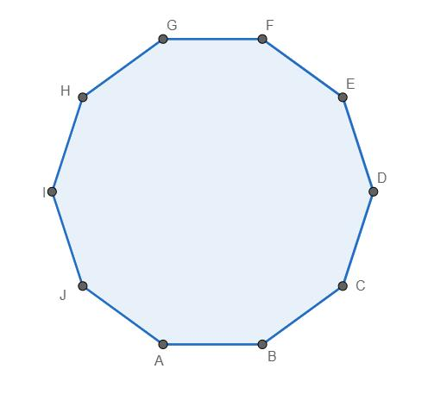
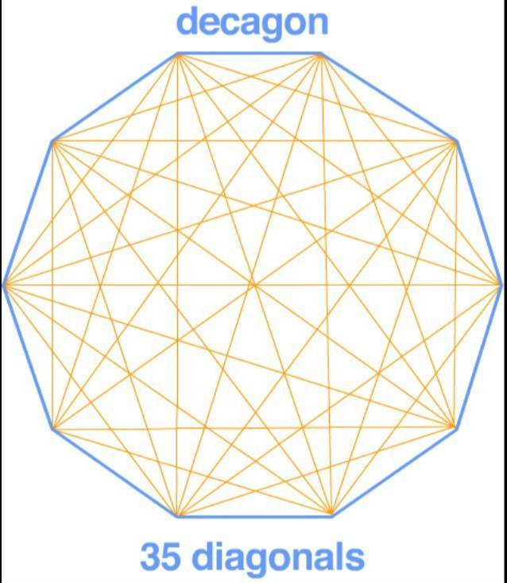
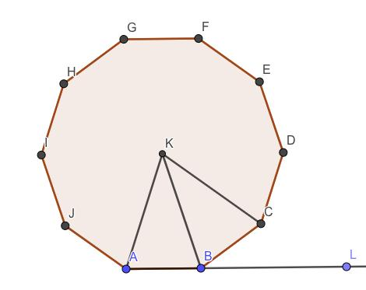
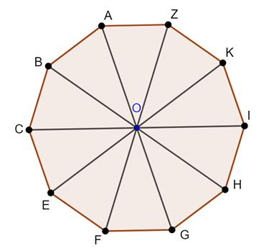
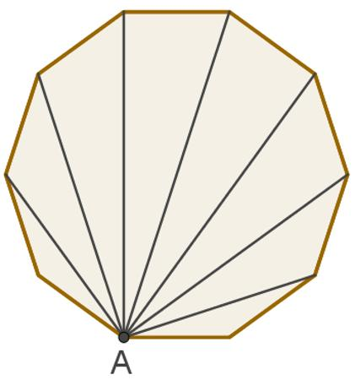
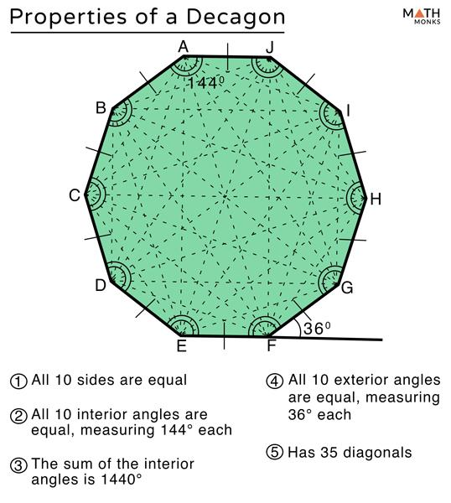
A convex decagon is a decagon in which every interior angle is less than ${180}^{∘}$.
Properties
- All 10 interior angles are $<{180}^{∘}$.
- It has no inward indentation.
- Every diagonal lies completely inside the decagon.
- Every line segment connecting two points of the decagon remains inside it.

Concave Decagon
# Source: AI Source: Provided by: [Data Path: Persons Table -> ID Column: 1, Name_En Column: Motasem Essam] -> From: [ChatGPT] on [7/25/2026]
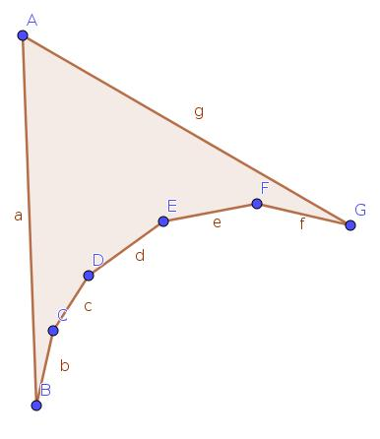
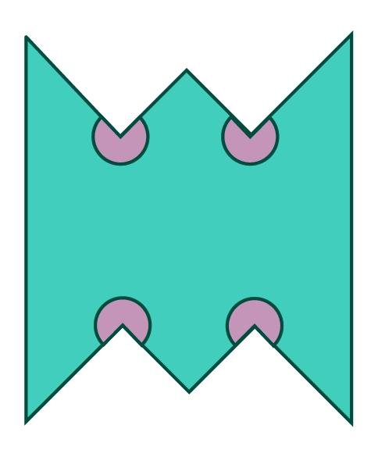
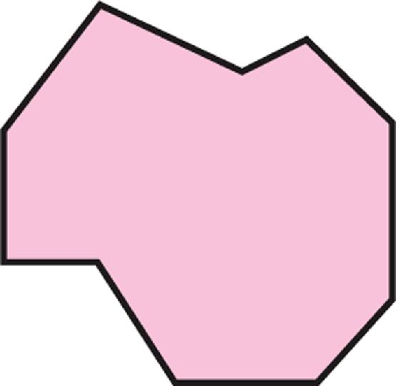
A concave decagon is a decagon with at least one interior angle greater than ${180}^{∘}$.
Properties
- At least one interior angle is $>{180}^{∘}$.
- It has an inward indentation.
- At least one diagonal lies partly outside the decagon.
- It is not convex.

Regular Decagon
# Source: AI Source: Provided by: [Data Path: Persons Table -> ID Column: 1, Name_En Column: Motasem Essam] -> From: [ChatGPT] on [7/25/2026]
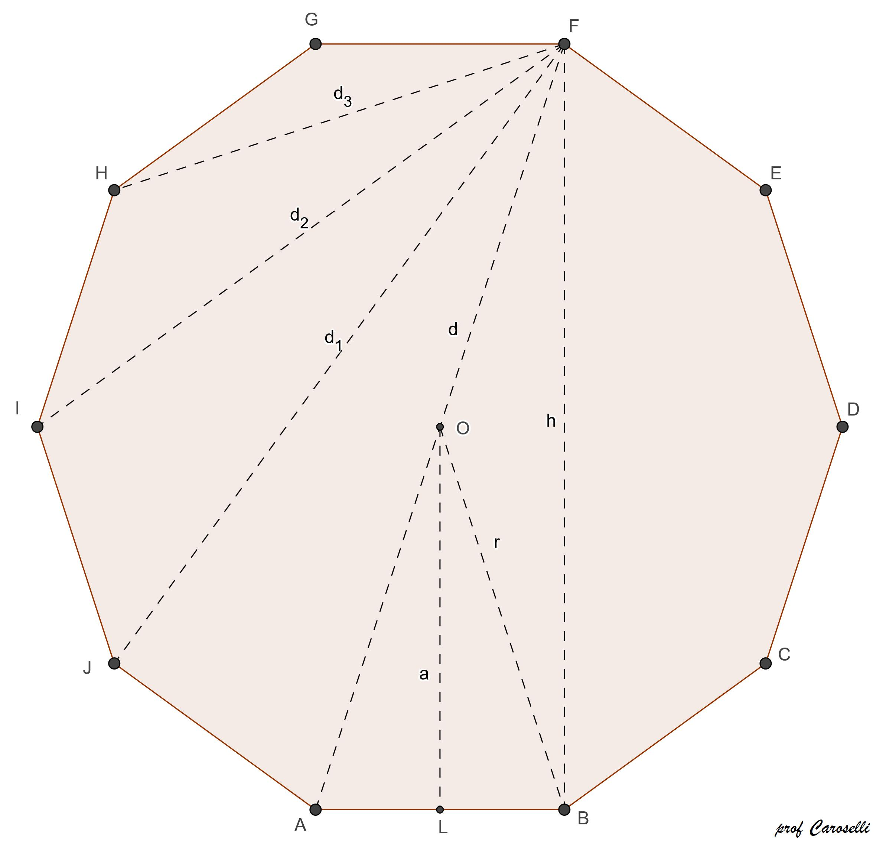
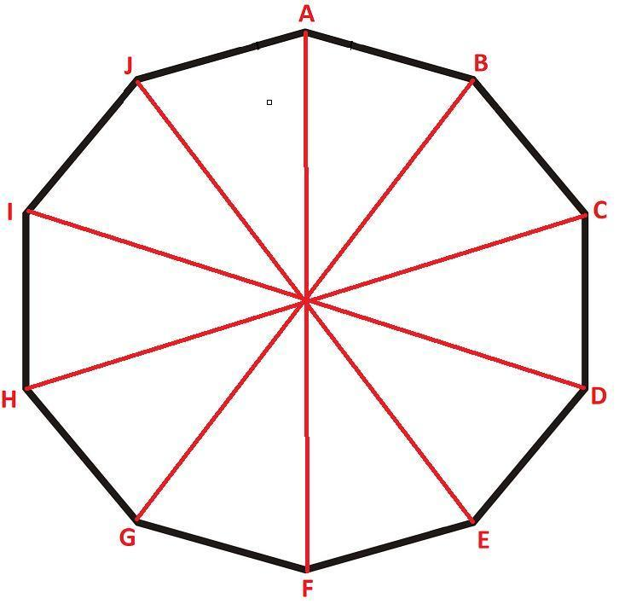
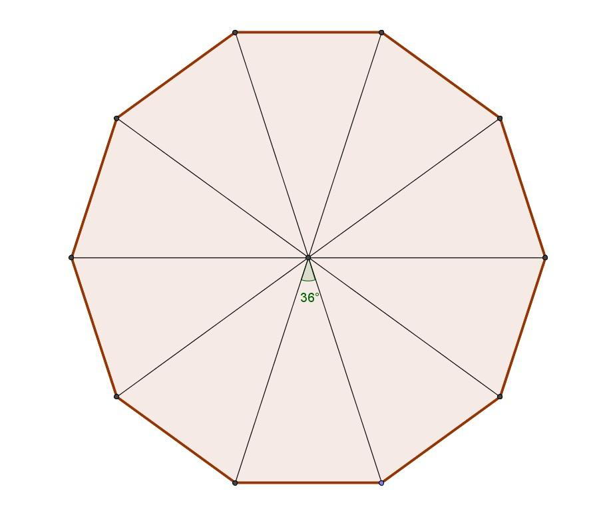
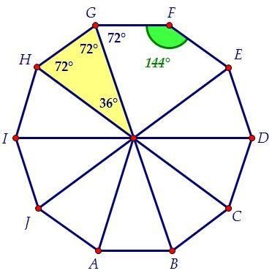
A regular decagon has:
- 10 equal sides
- 10 equal interior angles
Interior Angle Sum
For any decagon:
$$\left(10-2\right)×{180}^{∘}={1440}^{∘}$$
Therefore, each interior angle of a regular decagon is:
$$\frac{{1440}^{∘}}{10}=\boxed{{144}^{∘}}$$
Exterior Angle
$$\frac{{360}^{∘}}{10}=\boxed{{36}^{∘}}$$
Central Angle
$$\frac{{360}^{∘}}{10}=\boxed{{36}^{∘}}$$
Perimeter
If each side has length $a$:
$$\boxed{P=10a}$$
Area
For a regular decagon:
$$\boxed{A=\frac{10a^{2}}{4\tan{{18}^{∘}}}}$$
or equivalently:
$$\boxed{A=\frac{5a^{2}}{2\tan{{18}^{∘}}}}$$
Symmetry
A regular decagon has:
- 10 lines of symmetry
- Rotational symmetry of order 10
- Smallest rotational angle: ${36}^{∘}$

Irregular Decagon
# Source: AI Source: Provided by: [Data Path: Persons Table -> ID Column: 1, Name_En Column: Motasem Essam] -> From: [ChatGPT] on [7/25/2026]
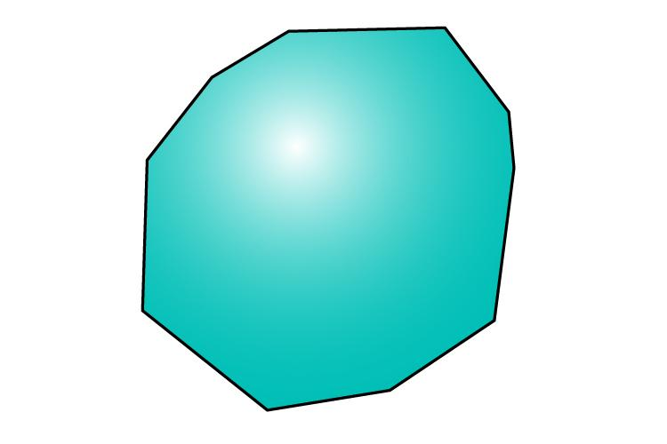
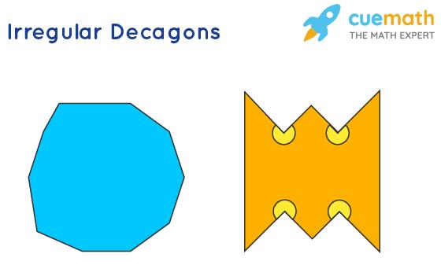
An irregular decagon is a decagon that does not have all ten sides and all ten angles equal.
It may have:
- Different side lengths
- Different angle measures
- Some equal sides
- Some equal angles
- Reflection symmetry
- Rotational symmetry
- No symmetry
An irregular decagon may be either convex or concave.

Symmetric Decagon
# Source: AI Source: Provided by: [Data Path: Persons Table -> ID Column: 1, Name_En Column: Motasem Essam] -> From: [ChatGPT] on [7/25/2026]
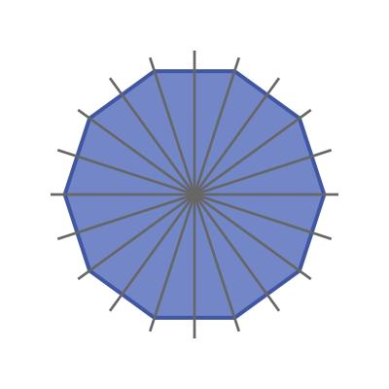
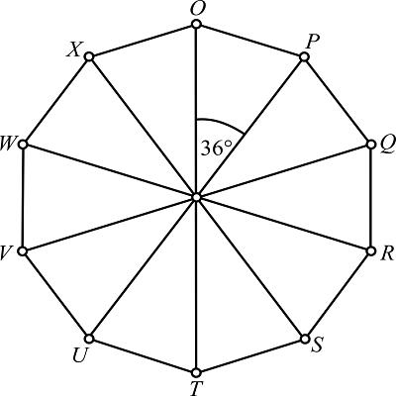

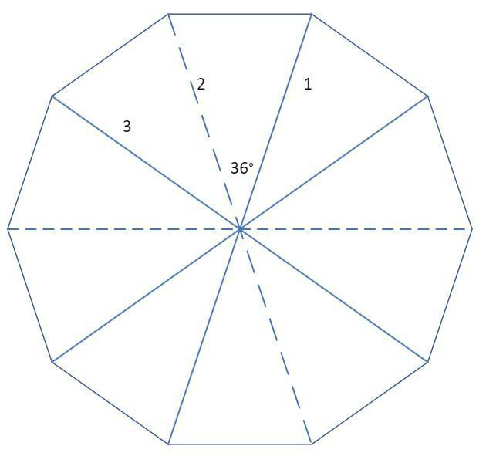
A symmetric decagon has at least one nontrivial symmetry.
It may have:
- Reflection symmetry
- Rotational symmetry
- Or both
A regular decagon has 10 lines of reflection symmetry and rotational symmetry of order 10.

Asymmetric Decagon
# Source: AI Source: Provided by: [Data Path: Persons Table -> ID Column: 1, Name_En Column: Motasem Essam] -> From: [ChatGPT] on [7/25/2026]
An asymmetric decagon has:
- No line of reflection symmetry
- No nontrivial rotational symmetry
It can still be either convex or concave.

Interior Angle Sum
# Source: AI Source: Provided by: [Data Path: Persons Table -> ID Column: 1, Name_En Column: Motasem Essam] -> From: [ChatGPT] on [7/25/2026]
For any decagon:
$$S=\left(10-2\right)×{180}^{∘} \\ \boxed{S={1440}^{∘}}$$
Thus, the sum of the ten interior angles of every decagon is ${1440}^{∘}$.
For a regular decagon:
$$\boxed{\text{Each interior angle}={144}^{∘}}$$

Number of Diagonals
# Source: AI Source: Provided by: [Data Path: Persons Table -> ID Column: 1, Name_En Column: Motasem Essam] -> From: [ChatGPT] on [7/25/2026]
The number of diagonals of an $n$-sided polygon is:
$$D=\frac{n\left(n-3\right)}{2}$$
For a decagon:
$$D=\frac{10\left(10-3\right)}{2} \\ D=\frac{10\left(7\right)}{2} \\ \boxed{D=35}$$
From each vertex, the number of diagonals is:
$$10-3=\boxed{7}$$

Triangulation
# Source: AI Source: Provided by: [Data Path: Persons Table -> ID Column: 1, Name_En Column: Motasem Essam] -> From: [ChatGPT] on [7/25/2026]
A convex decagon can be divided into:
$$n-2=10-2 \\ \boxed{8\text{ triangles}}$$
Therefore, its interior-angle sum can also be calculated as:
$$8×{180}^{∘}=\boxed{{1440}^{∘}}$$

Regular Decagon Measurements
# Source: AI Source: Provided by: [Data Path: Persons Table -> ID Column: 1, Name_En Column: Motasem Essam] -> From: [ChatGPT] on [7/25/2026]
For a regular decagon with side length $a$:
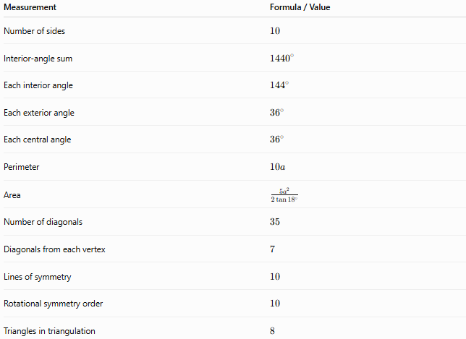
Measurement | Formula / Value
Number of sides | $$10$$
Interior-angle sum | $${1440}^{∘}$$
Each interior angle | $${144}^{∘}$$
Each exterior angle | $${36}^{∘}$$
Each central angle | $${36}^{∘}$$
Perimeter | $$10a$$
Area | $$\frac{5a^{2}}{2\tan{{18}^{∘}}}$$
Number of diagonals | $$35$$
Diagonals from each vertex | $$7$$
Lines of symmetry | $$10$$
Rotational symmetry order | $$10$$
Triangles in triangulation | $$8$$

Example
# Source: AI Source: Provided by: [Data Path: Persons Table -> ID Column: 1, Name_En Column: Motasem Essam] -> From: [ChatGPT] on [7/25/2026]
Suppose a regular decagon has side length:
$$a=5$$
Perimeter
$$P=10a \\ P=10\left(5\right) \\ \boxed{P=50}$$
Interior Angle
$$\boxed{{144}^{∘}}$$
Interior-Angle Sum
$$\boxed{{1440}^{∘}}$$
Number of Diagonals
$$\boxed{35}$$
Area
$$A=\frac{5{\left(5\right)}^{2}}{2\tan{{18}^{∘}}} \\ A=\frac{125}{2\tan{{18}^{∘}}} \\ \boxed{A≈192.36}$$

Real-World Examples
# Source: AI Source: Provided by: [Data Path: Persons Table -> ID Column: 1, Name_En Column: Motasem Essam] -> From: [ChatGPT] on [7/25/2026]
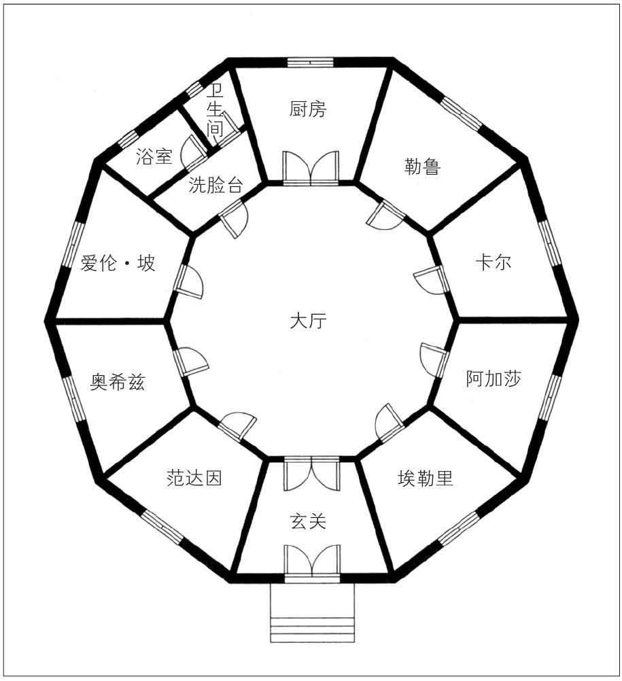
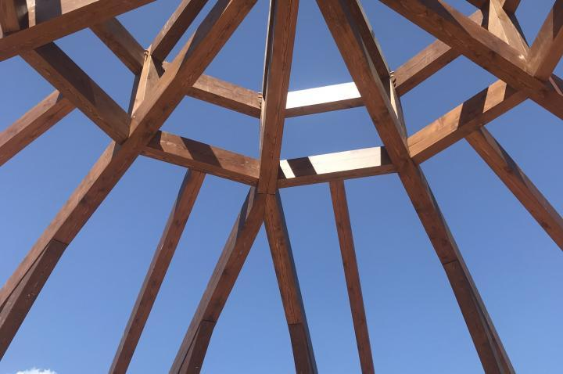
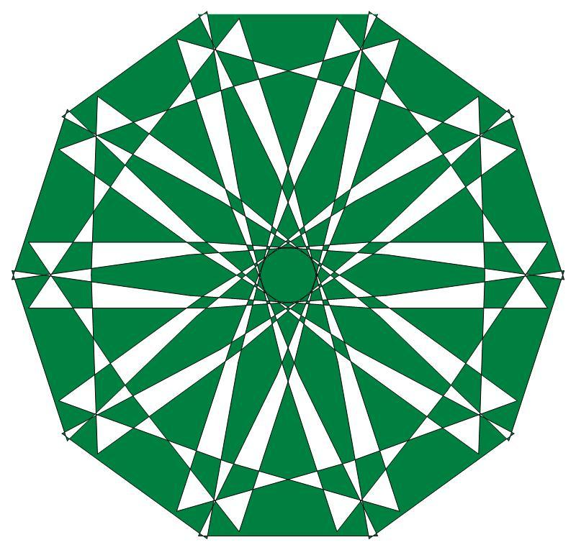
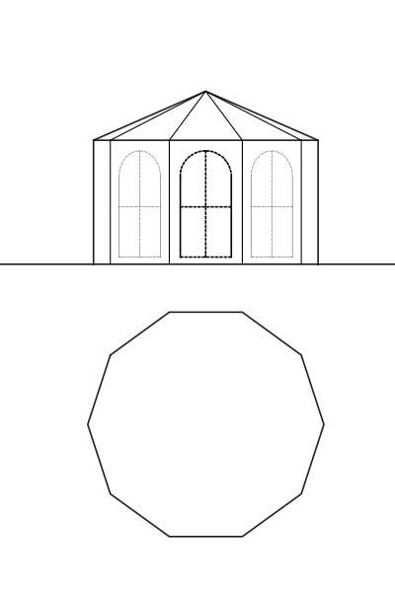
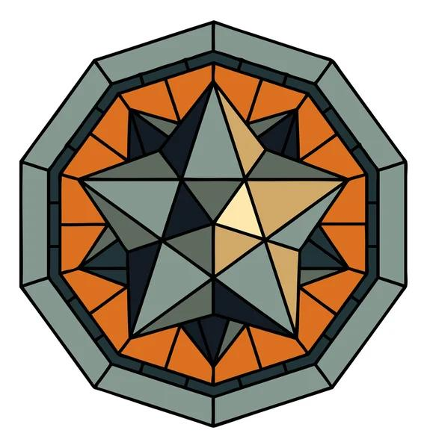
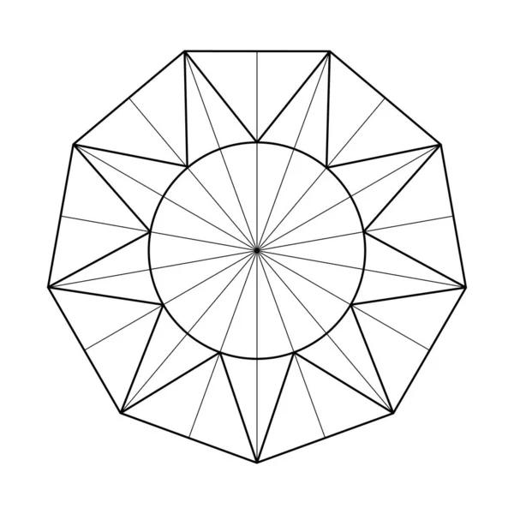
Decagonal shapes can appear in:
- Architecture
- Decorative designs
- Floor and tile patterns
- Logos
- Geometric artwork
- Specialized buildings and structures
- Computer graphics and geometric modeling

Relationship to Other Polygons
# Source: AI Source: Provided by: [Data Path: Persons Table -> ID Column: 1, Name_En Column: Motasem Essam] -> From: [ChatGPT] on [7/25/2026]
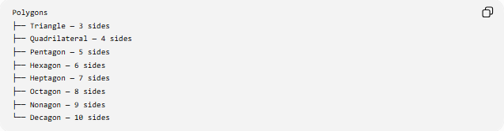
Polygons
├── Triangle — 3 sides
├── Quadrilateral — 4 sides
├── Pentagon — 5 sides
├── Hexagon — 6 sides
├── Heptagon — 7 sides
├── Octagon — 8 sides
├── Nonagon — 9 sides
└── Decagon — 10 sides
A decagon follows the general polygon formulas:
$$\boxed{S=\left(n-2\right){180}^{∘}}$$
and
$$\boxed{D=\frac{n\left(n-3\right)}{2}}$$
For $n=10$:
$$S={1440}^{∘} \\ D=35$$

Key Points
# Source: AI Source: Provided by: [Data Path: Persons Table -> ID Column: 1, Name_En Column: Motasem Essam] -> From: [ChatGPT] on [7/25/2026]
- A decagon has 10 sides.
- It has 10 vertices and 10 interior angles.
- Its interior-angle sum is ${1440}^{∘}$.
- A regular decagon has interior angles of ${144}^{∘}$.
- Each exterior angle of a regular decagon is ${36}^{∘}$.
- Each central angle of a regular decagon is ${36}^{∘}$.
- A decagon has 35 diagonals.
- 7 diagonals originate from each vertex.
- A convex decagon can be divided into 8 triangles.
- A regular decagon has 10 lines of symmetry.
- A regular decagon has rotational symmetry of order 10.

Conclusion
# Source: AI Source: Provided by: [Data Path: Persons Table -> ID Column: 1, Name_En Column: Motasem Essam] -> From: [ChatGPT] on [7/25/2026]
A decagon is a ten-sided polygon. It can be classified by convexity, regularity, and symmetry. The regular decagon has ten equal sides and angles, ${144}^{∘}$interior angles, ${36}^{∘}$exterior and central angles, 35 diagonals, and 10-fold rotational symmetry.

